**NetReveal Autofeed**

**Testing for Multiple Transaction ID’s**

**Main Menu 🡪 Suppliers 🡪 ANZ Supplier Sanctions 🡪 Supplier Sanctions Scm Report**

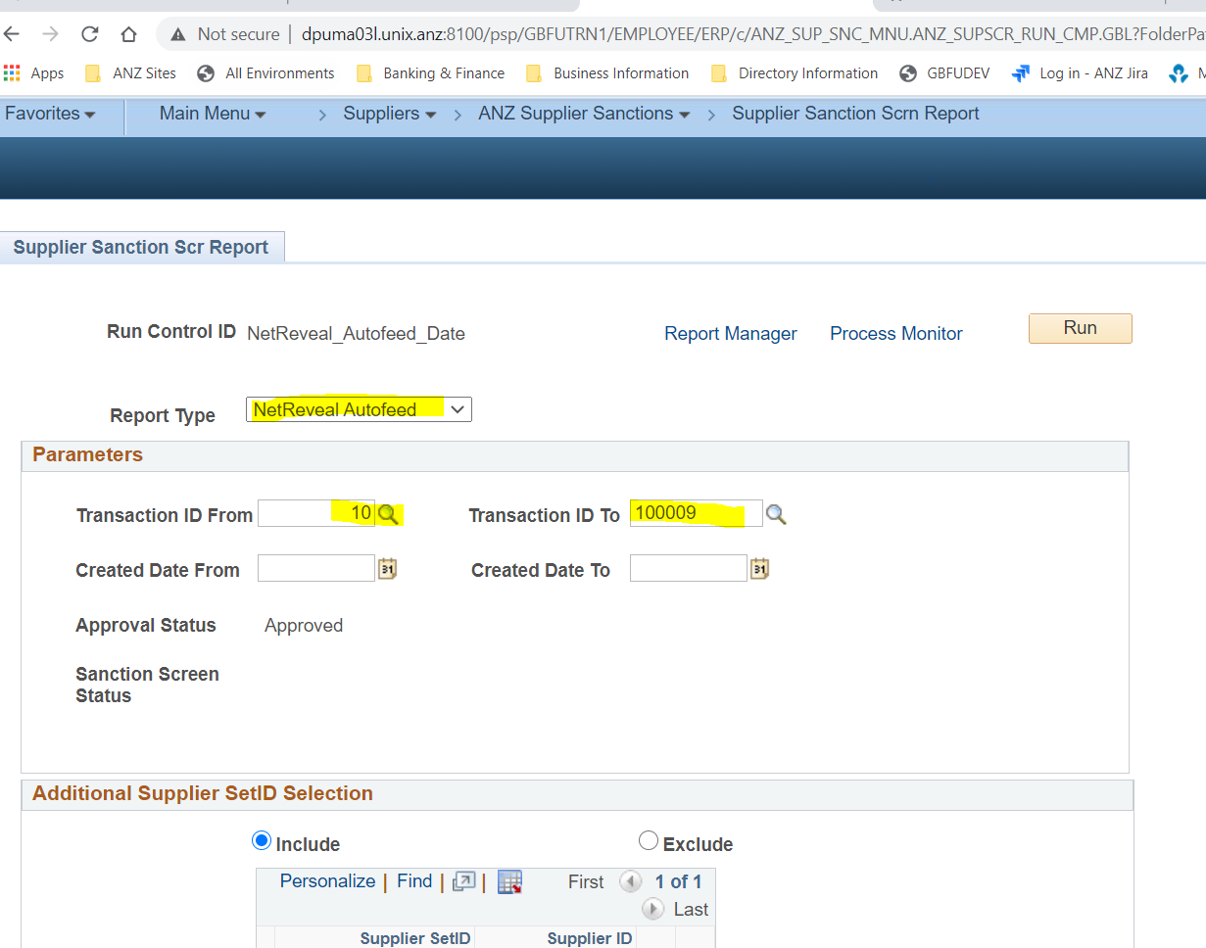

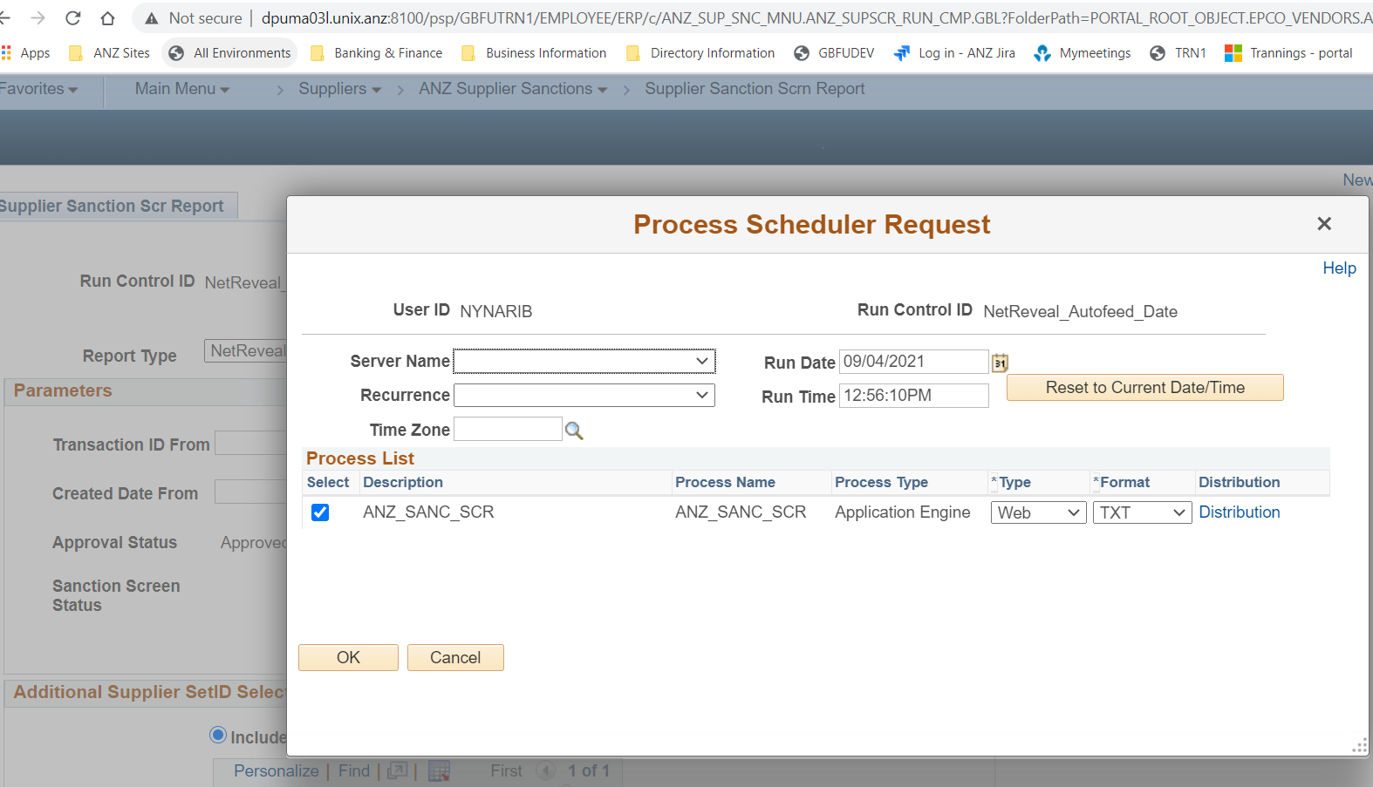

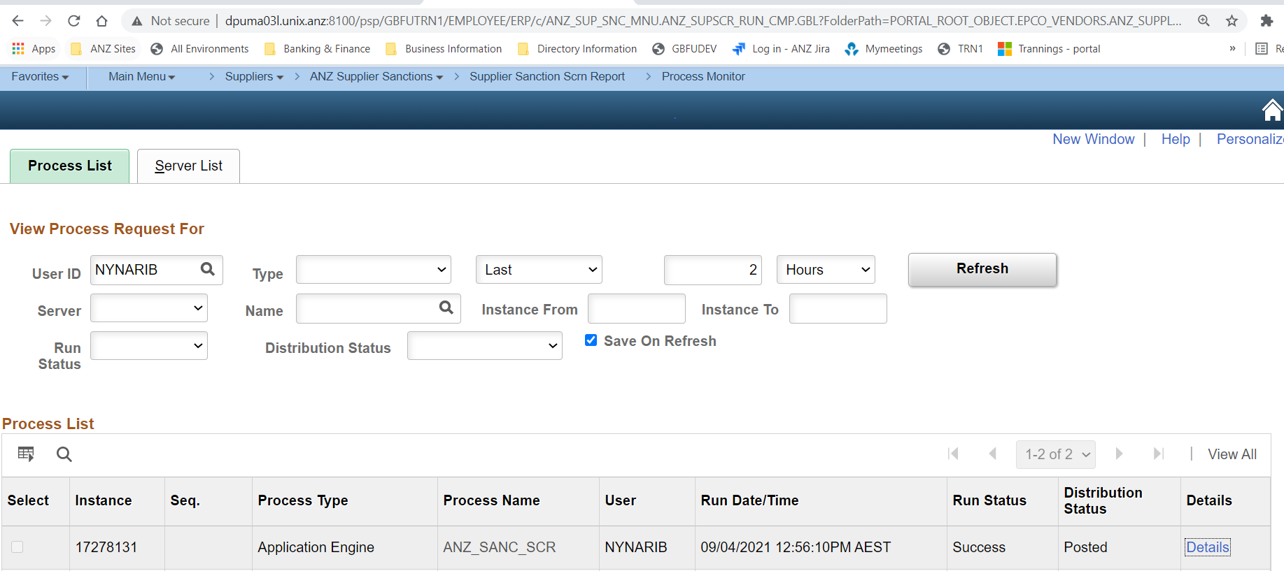

Tag and Dat file generated with today date as 20210409

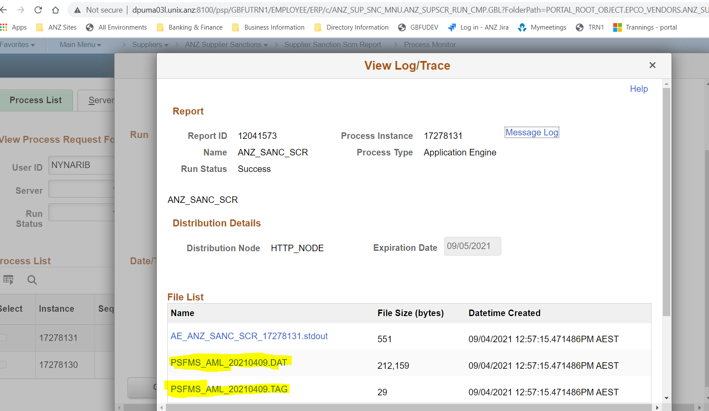

Date is populating in the file as accepting shown below

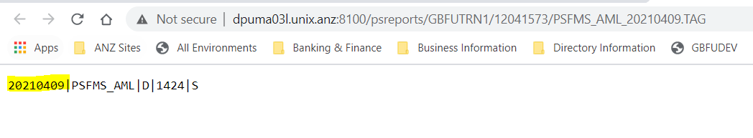

Verifying AE_ANZ_SANC_SCR_17278131.stdout STD out file to check the date

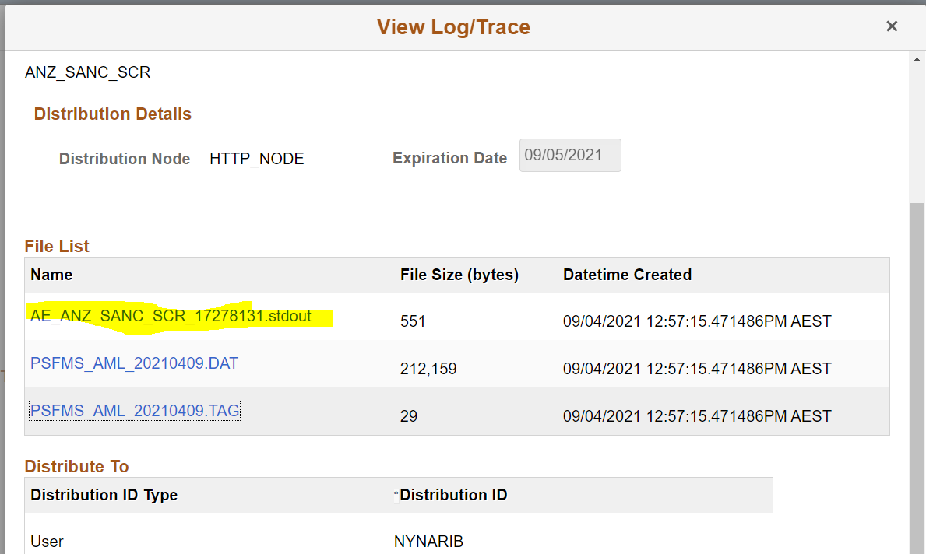

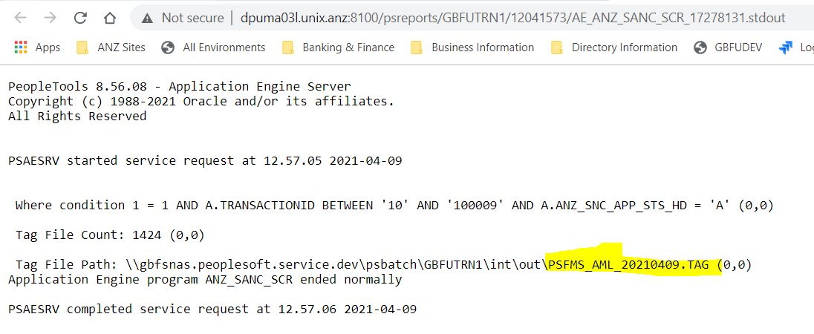

Verifying count match between Dat file and Tag file where the test is passed

Tag file having 1424 lines

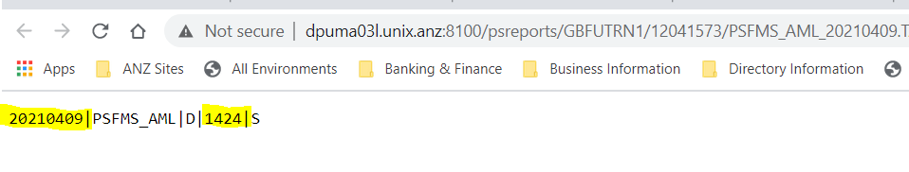

Dat file count

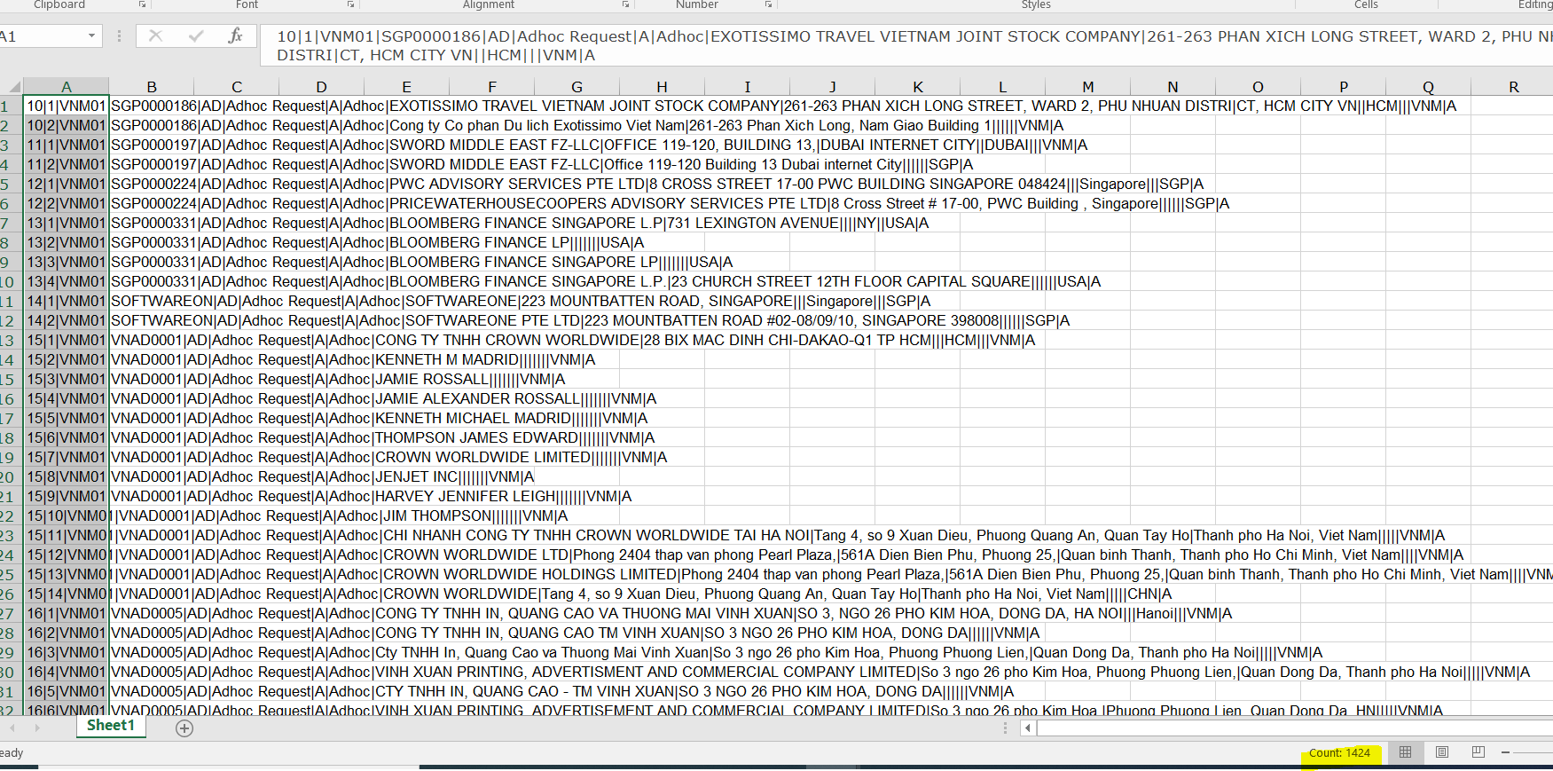



**Testing between Date Range**

**Main Menu 🡪 Suppliers 🡪 ANZ Supplier Sanctions 🡪 Supplier Sanctions Scm Report**

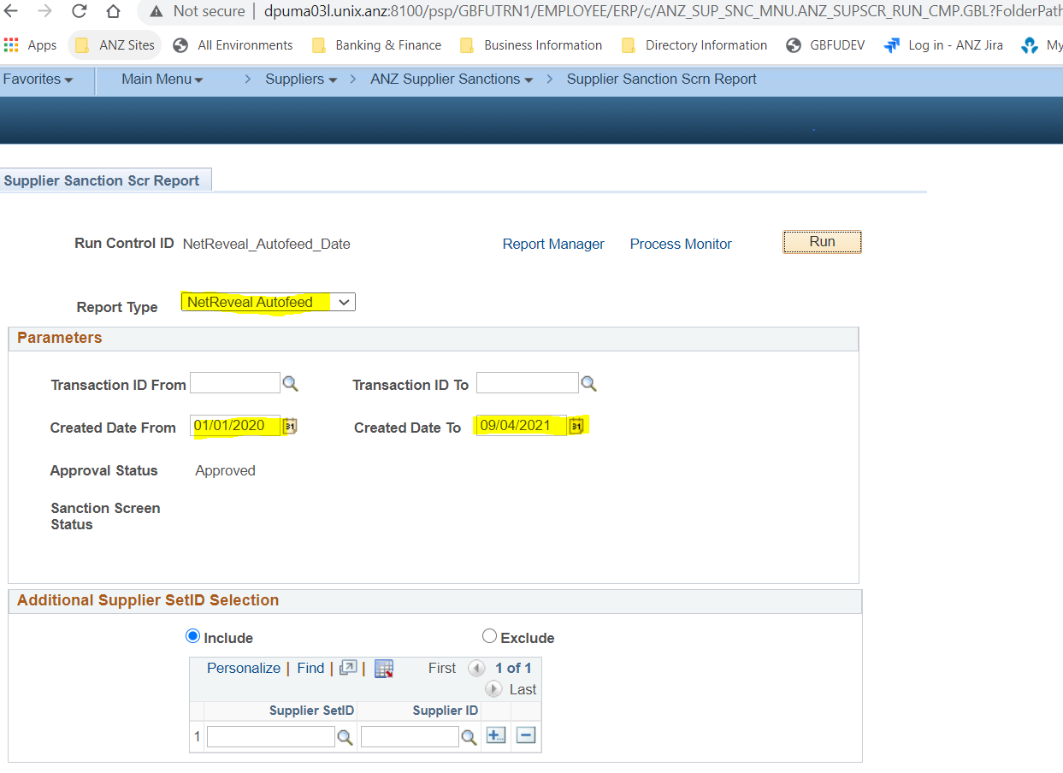

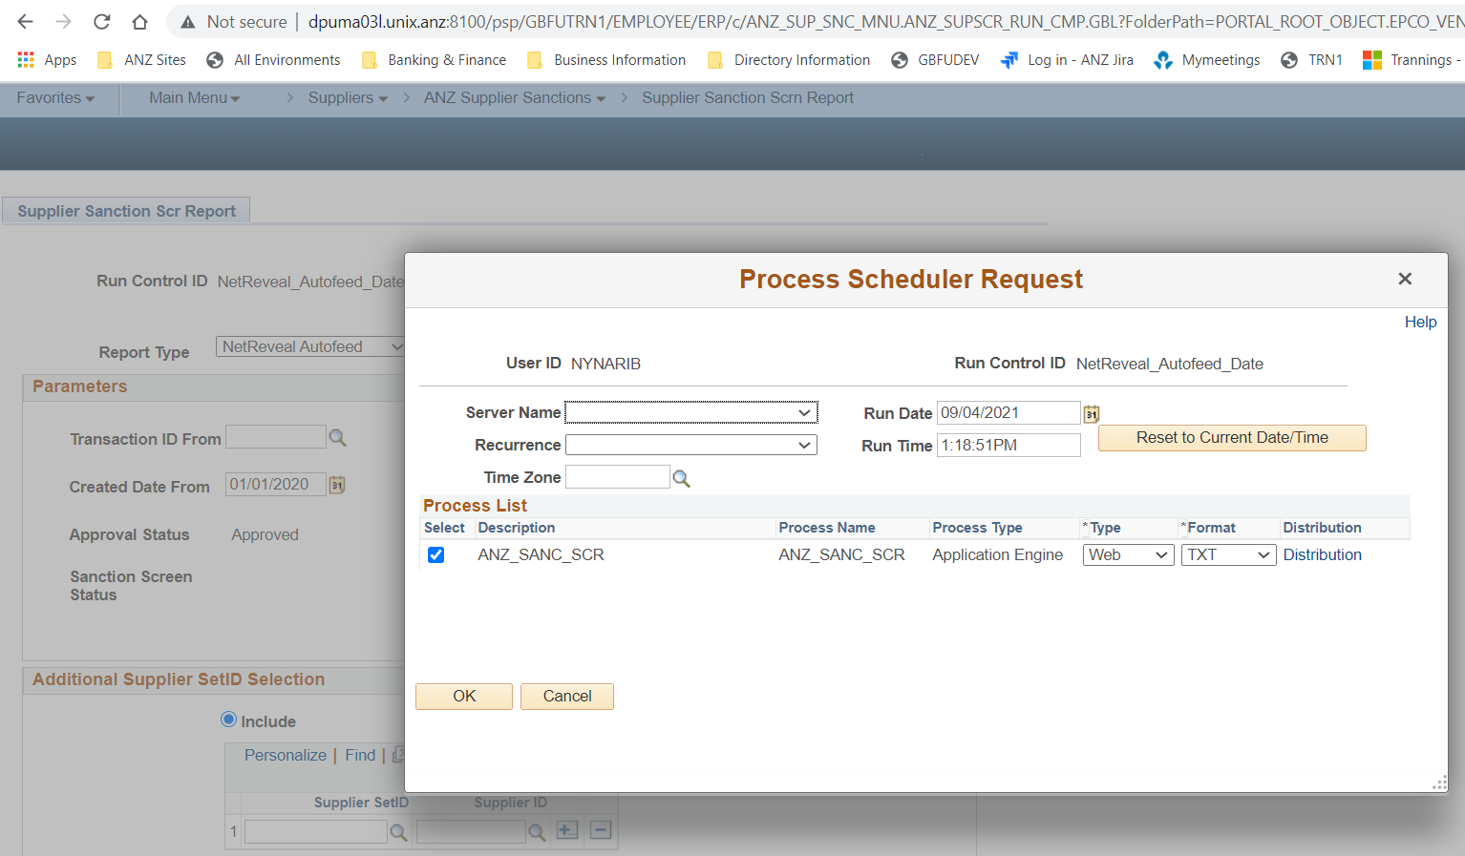

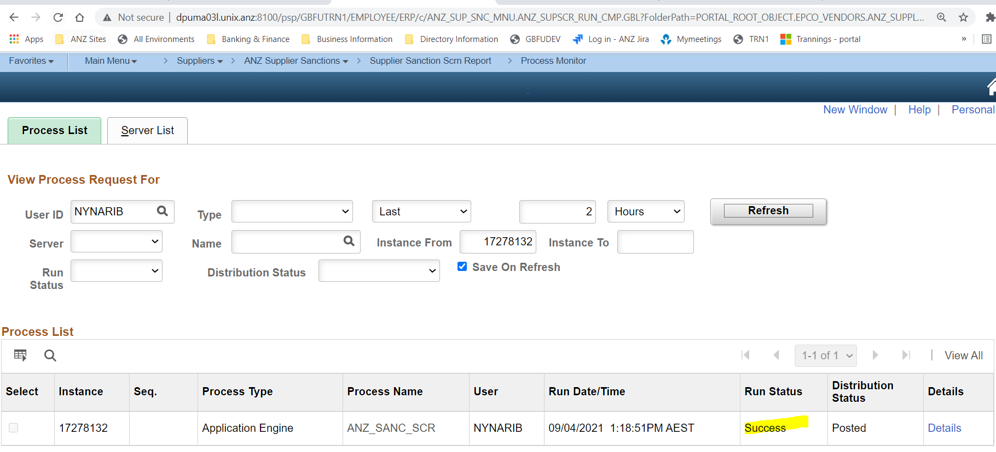

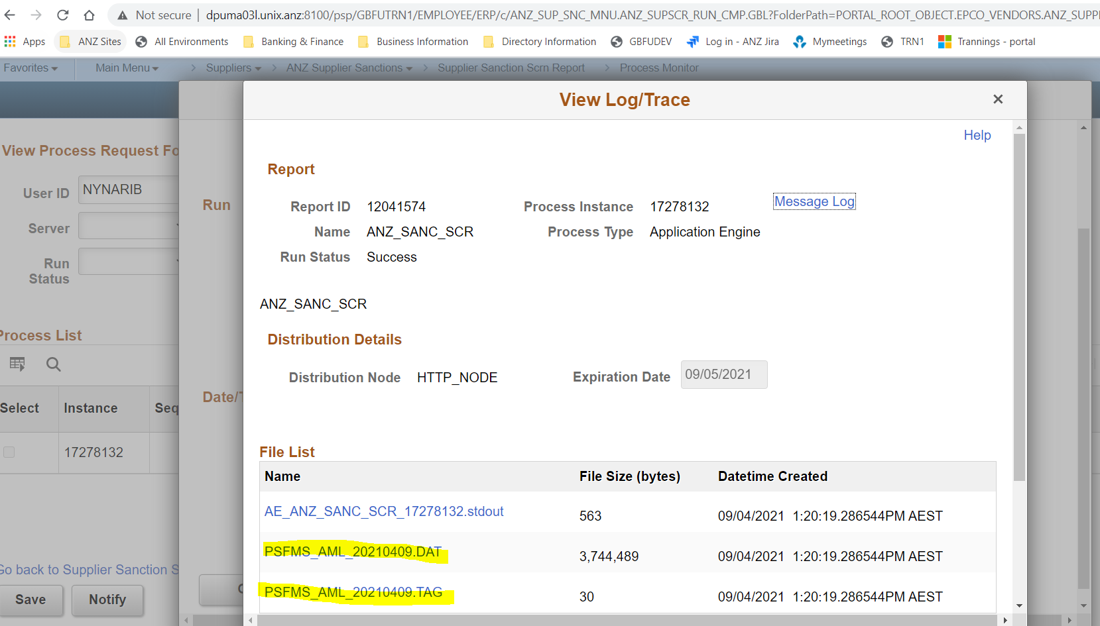

Tag file output result

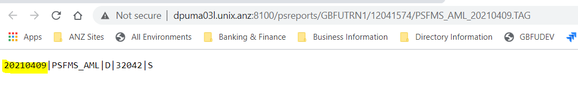

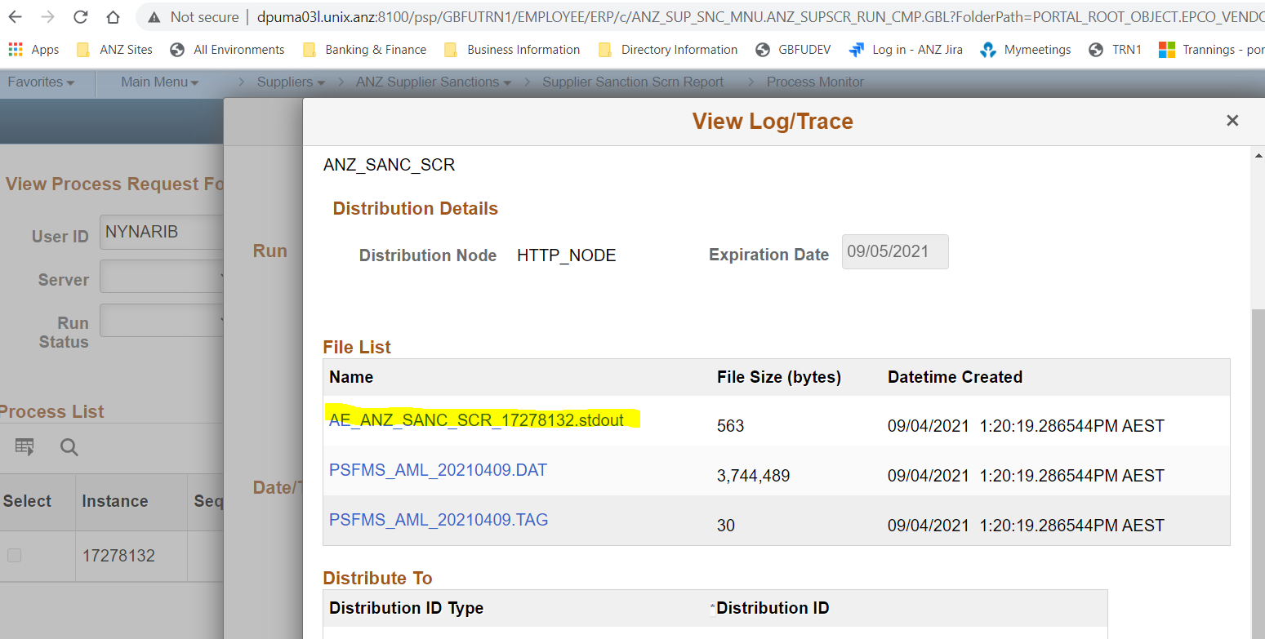

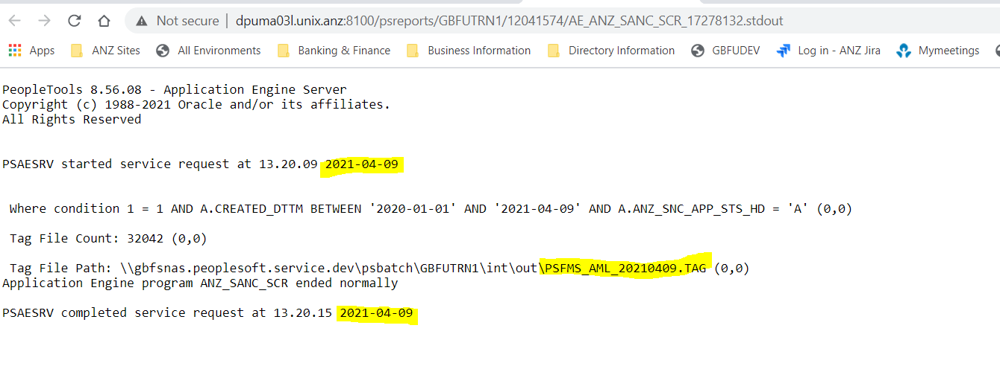

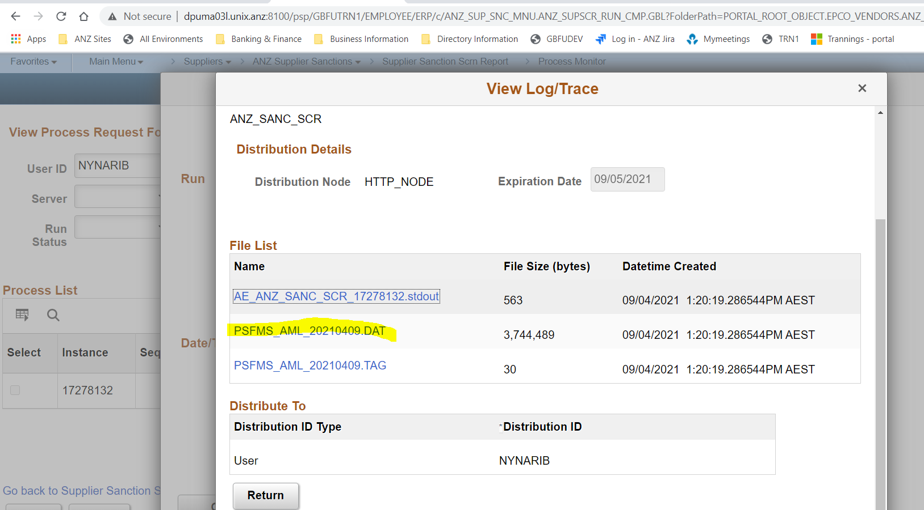

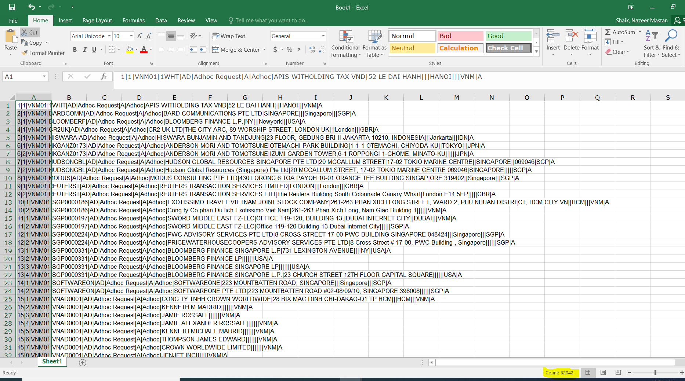

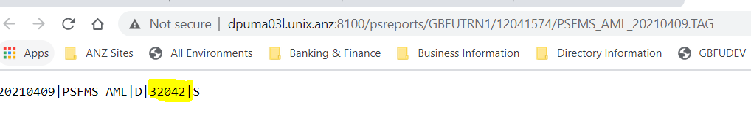



**Testing without providing any data in below fields**

**Main Menu 🡪 Suppliers 🡪 ANZ Supplier Sanctions 🡪 Supplier Sanctions Scm Report**

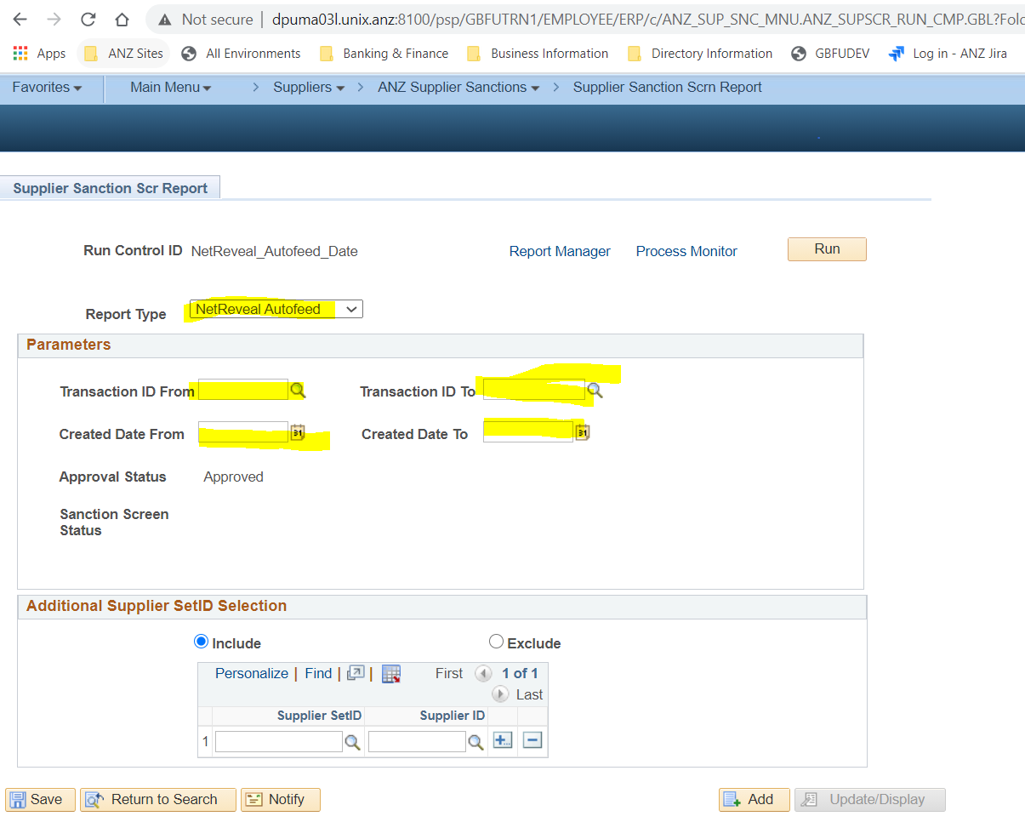

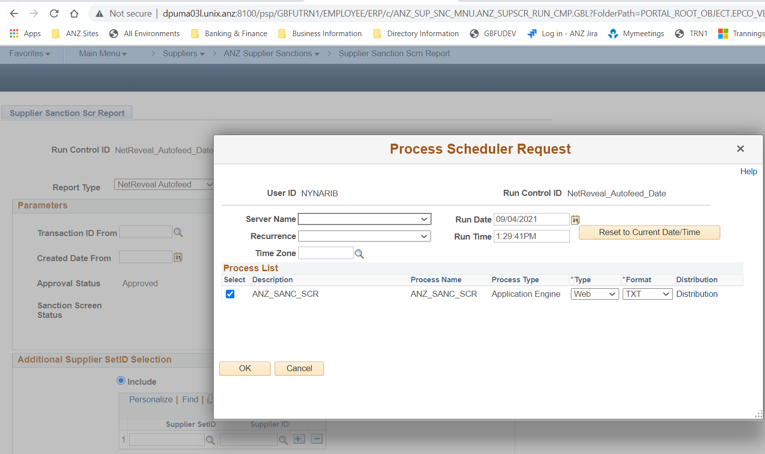

**Process ran to Success**

